Council Tax Consultation Briefing
Croydon Council have announced a consultation on their proposed changes to the council tax support provided by Croydon Council. The consultation opened on the 28th October 2021 and will run until the 9th December 2021. This is a 6 week consultation which seeks to change Council Tax Support entitlement
Explanation of terms:
Council tax support = financial support available to people to help manage their council tax
Claimant = person applying for support with their council tax
None-dependant = someone over 18 and living with you as part of your household
None-dependant deduction = reduction made to the financial support you receive due to someone over 18 living with you as part of your household
Means tested benefits = Claimants need to show a 'means' of income and capital below a certain level to get means tested benefits 2021. A current list of means-tested benefits would include: Council Tax Support, Housing Benefit, Income-based Jobseeker's Allowance (JSA), Income-related Employment and Support Allowance (ESA), Income Support, Pension Credit, Tax Credits, Child Tax Credit, Working Tax Credit, Universal Credit. To be eligible you typically have limited means, capital, and savings.
What concerns have been raised:
- There is only limited provision of welfare rights in the advice sector as the Council until its cuts was the main provider of this. Welfare rights advice is underfunded in the advice sector.

- The system that has been proposed is complex and low-income families will need budgeting advice if they are going to avoid going into debt and help once they are in debt.

- Could lead to an increase in homelessness as household members may be asked to leave their homes if unable to pay contributions where Council Tax Support has been reduced. We know that this can be a factor in homelessness applications as main tenants are unable to deal with the reduction in their housing benefit caused by the non-dependant deduction.

- There are 25,443 households in Croydon who are fuel poor and considered to be in fuel poverty. Many of whom are likely to be reliant on the existing Council Tax Support scheme.

- Financial pressures on low-income households have recently included a Universal Credit reduction of £87 per month and fuel cost increase up to 30%. Our lowest income households and families are already adapting to new extreme financial pressures. This proposal will likely push those struggling households towards indebtedness and those in debt further.

- The change to entitlement that will mean that council tax support criteria will not just be based on the two main account holders it will be based on everyone in the household's income. This would have a disproportionate effect on BAME households who are more likely to be multigenerational.

- These changes will affect some of the lowest income households in the borough including carers and lone parents of children under 5.

- Lack of clarity over the administration and promotion of the Hardship Fund. This is part of the local authority duty to protect residents through any council tax changes.

- Households earning over £23,400 per year are ineligible for council tax support, unless care leavers or pensioners. You may be receiving Universal Credit and hitting this threshold due to childcare and rent costs.
- This proposal is likely to push many low-income families further into debt. For many people who end up in arrears with their Council Tax will find themselves facing the bailiffs with the devasting effects that this type of recovery causes

What has been raised about the consultation process:
- This is a 6 week consultation that will affect 15,000 households in Croydon. Local Government Association state: Best practice suggests you should plan for up to six to 12 weeks for a consultation exercise. Consultations of this level of impact should run for 12 weeks.

- Everyone has been invited to respond who has “an interest in the level of council tax support provided by the council” including business owners, workers and visitors in the borough.

- Key stakeholders’ engagement hasn’t focused on groups supporting those most affected by these changes.

- Online option available to feedback to the consultation. Telephone or post option not published on website so not known to be available.

- The consultation doesn’t mention what will happen to people in receipt of means tested welfare support or what the specific changes are for them.

• Not everyone who receives Council Tax Support is aware of this consultation.

What exists at the moment?

Who is currently considered vulnerable and entitled to full Council Tax Support
A lone parent with one or more dependants aged less than five years,
and applicant who receives, or any partner who receives -
• income support, or
• employment and support allowance, or
• disability living allowance, or
• personal independence payment, or
• the universal credit capability for work element
*If you receive Personal Independence Payment or Disability Living Allowance you can be considered disabled. These payments are to help manage your disability and you can receive them if you are working or not.

Deductions are not made to your applicable support amount if you are receiving:
• Universal Credit
• Income support
• Job Seekers Allowance (income based)
• Employment Support (income related)
• Guaranteed Pension Credit

If you have more than £8,000
If you have more than £8,000 in capital, you will not be able to get Council Tax Support, unless you are a lone parent with a child under 5 years old or you or your partner receive at least one of the following:
• Guarantee Pension Credit
• Employment Support Allowance (income related and contribution based)
• Disability Living Allowance (DLA) or Personal Independence Payment (PIP)
• Incapacity Benefit
If you have more than £16,000
If you have more than £16,000, you will not be able to get Council Tax support unless you or your partner receives a Guaranteed Pension Credit.
Protecting the vulnerable – Residents who are either pensioners, or working age residents who receive Disability Living Allowance, Personal Independence Payments or Employment and Support Allowance (part work related), residents who are in receipt of Income Support or a Single Parent with a child under 5 receive the same level of Council Tax Support as they did under the Council Tax Benefit Scheme.

What is the proposal? Can be found on the council website:
https://www.getinvolved.croydon.gov.uk/proposed-changes-to-our-council-tax-support-scheme
- Introduction of a Hardship Payment
The council will introduce a Hardship Payment for people transitioning from their existing Council Tax Support entitlement.
- Non-dependant deductions (for people aged 18 or over in the household)
Other adults living in a household will be expected to contribute something towards council tax. This is called a non-dependant deduction, for people aged 18 or over, who are not the claimant or partner, and there are three revised flat rate levels as follows:
£5 per week – non working
£10 per week – gross wages of £22,999 or less
£30 per week - gross wages of £23,000 or above
A deduction is an amount taken off a claimant’s council tax support (CTS) entitlement on the basis that it is expected that other adults will contribute towards council tax

- Change in entitlement for disabled residents
Where a disabled resident is working the council will disregard (remove) £50 from their earned income prior to calculation of CTS under and income banded scheme in order to provide additional protection.
You are no longer entitled to the full Council Tax Support scheme if you are working and receive Disability Living Allowance or Personal Independence Payment for your disability.
A change for carers in receipt of Carers Allowance and other low-income households.

The consultation suggests a proposed income related scheme could look like this:
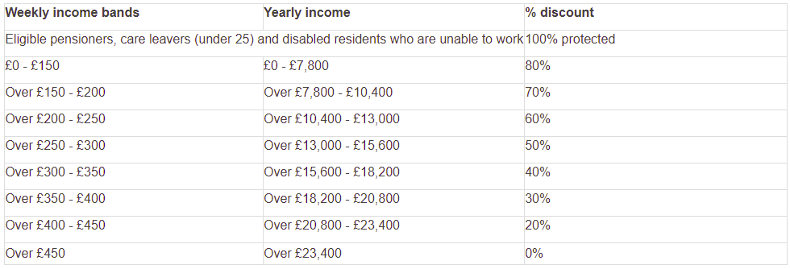

*Carers Allowance is £67.60 per week. This change could mean carers are now expected to pay 20% or over to meet the new short fall in their council tax support.
*Lone parents with children under 5 in receipt of Income Support will have to pay 20% or over towards the new short fall in their council tax support.
What can you do?
Make sure you respond to the consultation at : https://www.getinvolved.croydon.gov.uk/proposed-changes-to-our-council-tax-support-scheme
Go and speak to your local Councillor at one of their Councillor surgeries so they are aware of your feelings on this issue. Find your ward councillor and details of their surgeries here: https://democracy.croydon.gov.uk/mgMemberIndex.aspx?bcr=1
You can also write to your Councillor. If you are not sure how to write to your Councillor, you can use this helpful tool: www.writetothem.com

